**How Digital Health is Transforming Patient Care & Medical Diagnosis in Africa**

Africa’s healthcare landscape is undergoing a rapid transformation, fueled by digital technologies that are reshaping patient care and medical diagnostics. Despite this progress, significant challenges persist, including inadequate healthcare infrastructure, limited access to specialists, and delays in diagnosis. These issues often leave millions without timely or quality medical attention, exacerbating health disparities across the continent. However, the integration of digital health solutions is emerging as a powerful force in bridging these gaps, offering innovative approaches to enhance accessibility, efficiency, and accuracy in healthcare delivery.

Digital health is proving to be a game-changer, with telemedicine enabling remote consultations, AI-powered diagnostics enhancing disease detection, and mobile health solutions improving patient engagement. Additionally, electronic health records are streamlining data management, ensuring better coordination among healthcare providers. Platforms like WHX Lagos and WHX Labs Lagos (formerly Medic and Medlab West Africa) are at the forefront of this transformation, serving as hubs for showcasing cutting-edge digital health advancements and fostering collaboration within the industry. By leveraging technology and fostering innovation, Africa is positioned for a future where quality healthcare is more accessible, efficient, and inclusive.

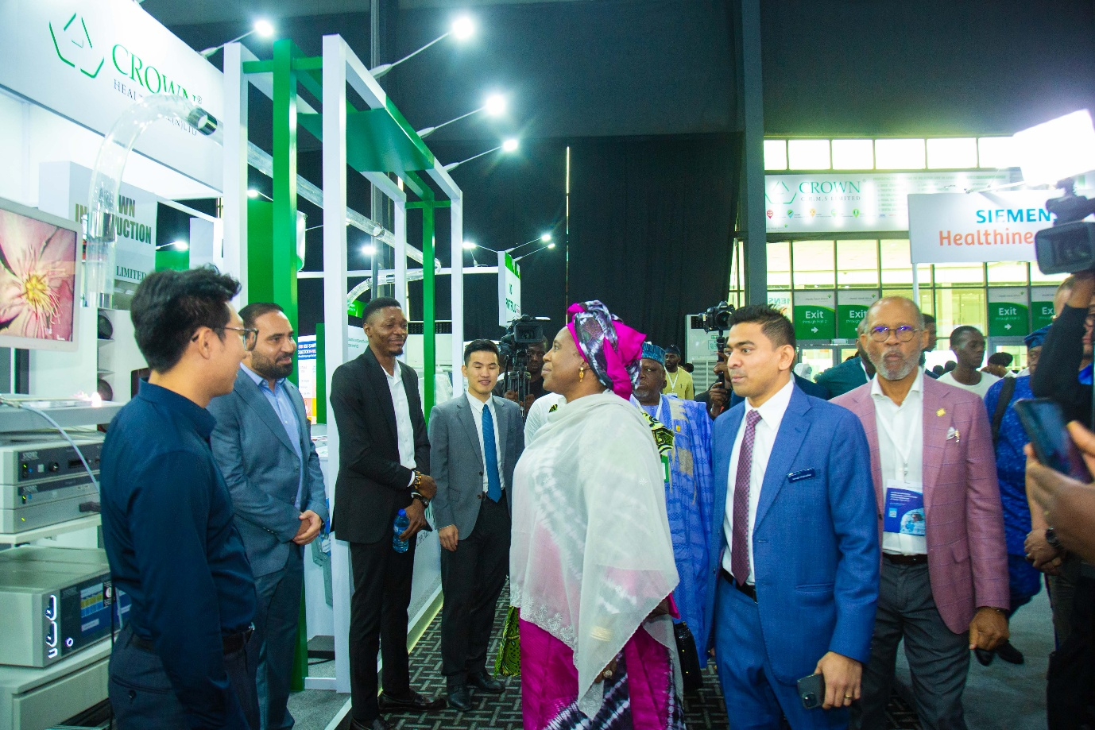

In Africa, digital health has been playing a crucial role in improving patient care. Telemedicine platforms and mobile health applications are gradually breaking geographical barriers by enabling patients to consult with doctors without the need for physical visits. This is especially impactful in regions where specialist doctors are scarce, ensuring that more people receive timely medical advice and prescriptions. AI-driven chatbots and virtual health assistants are also enhancing patient engagement, providing instant responses to health queries, and guiding individuals in managing their well-being. These tools are fostering a culture of self-care and preventive health management, reducing the burden on traditional healthcare systems.

Beyond consultations, digital health is also transforming chronic disease management through wearable devices and remote monitoring technologies. Patients with conditions such as diabetes, hypertension, and heart disease can now track vital health metrics in real time in the comfort of their homes, with data seamlessly shared with healthcare providers. This continuous monitoring allows for early interventions, reducing hospital visits and improving health outcomes. By leveraging mobile connectivity and smart algorithms, digital health solutions are empowering individuals to take a more proactive role in managing their health, ensuring better long-term care for those living with chronic illnesses.

More than ever before, artificial intelligence and machine learning are revolutionizing disease detection by enabling faster, more accurate assessments. AI-powered radiology tools can analyze medical images with precision, identifying anomalies that may be overlooked by the human eye. Similarly, digital pathology solutions and cloud-based diagnostic platforms are addressing Africa’s geographical challenges, allowing specialists to remotely review and interpret test results. Blockchain and big data analytics are further improving health record management, ensuring data security, interoperability, and reduced medical errors. These innovations are not only accelerating diagnosis but also enhancing patient safety and treatment efficiency.

Across Africa, several digital health success stories highlight the growing impact of technology in healthcare. Startups such as Helium Health in Nigeria and mPharma in Ghana are leading the way in electronic medical record digitization and pharmaceutical supply chain optimization, respectively. In another significant move to enhance Nigeria's healthcare system, the Federal Government inaugurated a 20-member committee on May 31, 2024, to implement the Nigeria Digital in Health Initiative (NDHI). This initiative aims to transform the nation's digital healthcare infrastructure by standardizing data collection and management across all health institutions. The committee, chaired by the Minister of State for Health and Social Welfare, Dr. Tunji Alausa, is tasked with developing a national unified Electronic Medical Records (EMR) platform. This platform is expected to improve patient experiences, protect data, and facilitate seamless data exchange, thereby strengthening public health monitoring and research capabilities. As funding, infrastructure and networking events continue to expand, Africa is poised to unlock even greater potential in digital health, transforming healthcare accessibility and outcomes for millions across the continent.

The recently rebranded healthcare and laboratory conference and exhibition, WHX Lagos and WHX Labs Lagos serve as key catalysts in Africa’s digital health revolution, providing a dynamic platform for networking, knowledge exchange, and business opportunities. The event brings together healthcare professionals, technology innovators, investors, and policymakers to explore groundbreaking solutions that address the continent’s healthcare challenges. Through interactive discussions, product showcases, and expert-led sessions. The event serves as a hub for fostering collaborations and accelerating the adoption of digital health innovations. It offers a space where startups can connect with investors, healthcare providers can explore new technologies, and regulators can gain insights into the evolving digital health landscape.

Key discussions at the 12th edition of West Africa’s premier healthcare and laboratory conference and exhibition will center around the transformative power of digital health, AI-driven diagnostics, West Africa Public Health, amongst others. Industry leaders and digital health experts will share insights on the latest trends, from AI-enabled health record management to wearable technology for chronic disease monitoring. Attendees will also experience live demonstrations of cutting-edge healthcare solutions, reinforcing the event’s role as a launchpad for innovation. By facilitating dialogue and showcasing real-world applications, WHX Lagos bridges the gap between technology developers and healthcare practitioners, ensuring digital health solutions are both scalable and impactful.

Digital health is not just a passing trend—it represents a fundamental shift in Africa’s healthcare landscape. As technological advancements continue to break down barriers and improve patient outcomes, platforms like WHX Lagos and WHX Labs Lagos will play a crucial role in sustaining this momentum. By bringing together key stakeholders and fostering cross-sector collaboration, the event is shaping the future of patient care and diagnostics in Africa. With continued innovation and investment, digital health has the potential to revolutionize healthcare accessibility, efficiency, and quality across the continent, ensuring that millions benefit from a more connected and technologically advanced healthcare ecosystem.